Middle of the Funnel Problems:

* Post Inquiry people are not aware that they have so many forms to fill out!

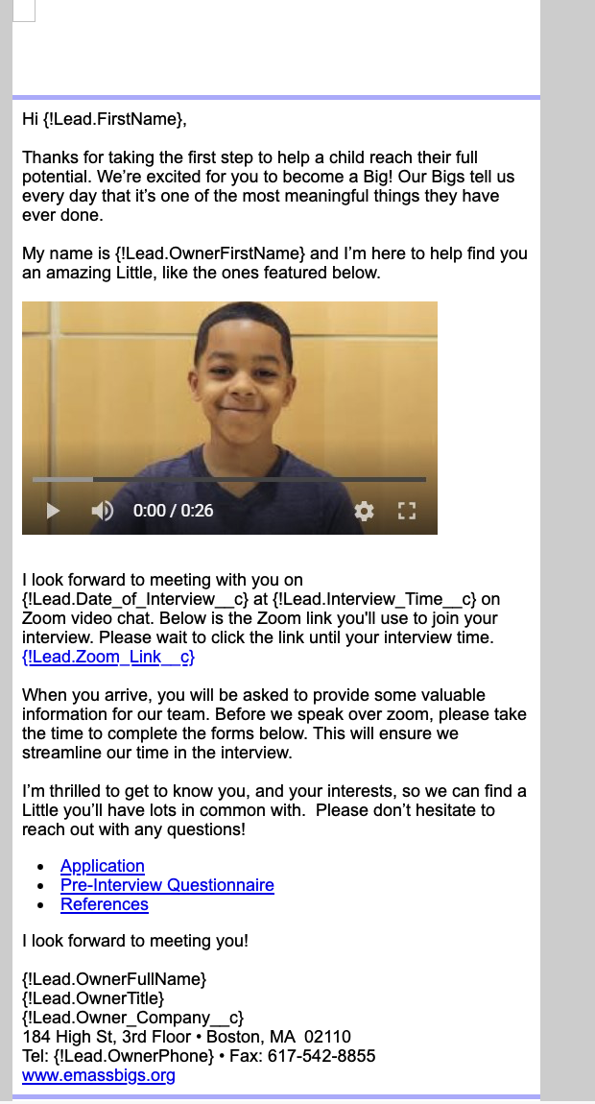

* Follow up email looks ot have error in the text wrapping and also grammar mistakes. There should be a “:” before the forms to know that those are the ones talked about
* Not sure I like “On Zoom Video Chat”
* “Take a child off of our waiting list” is really weird way to say things in my opinion

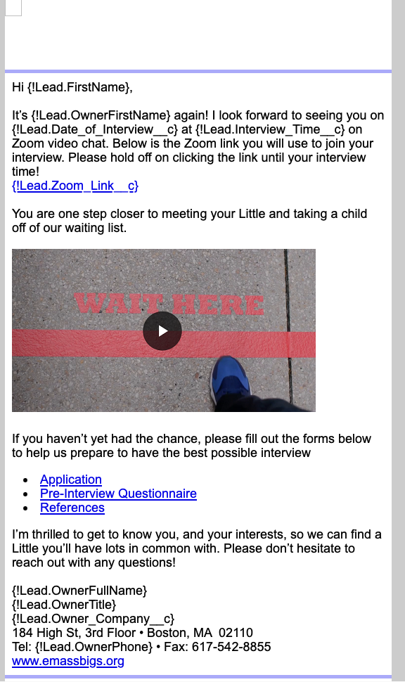

* Final outreach for zoom meeting has same formatting issue at the second one
* Also same video as second is repetitive.

